Rotor Dynamics software in Matlab
Planned capabilities of the Matlab program to be written during 17.8 until 17.8

Izhak Bucher

General features:
- Matlab 4.2 and Matlab 5.x compatible
- Input template file
- Geometry
- Bearing coefficients
- Damping (internal/external)
- External forcing
- Unbalance
- Connectivity
- misalignment
- Coupling to other structural systems (flexible foundation)
- Couple models to Structural Dynamics Toolbox FE models
- Coupling to linearised AMB models
- Bending and torsion dynamics
- Coupling forces between models
- Simulink compatibility
- Ability to embed a rotordynamic model in a Simulink diagram
- Nonlinear effects
- Coupling with other models/systems
- Active magnetic bearings (full nonlinear model)
- Squeeze-film damper
- Analysis capabilities
- Eigenvalues / eigenvectors
- Frequency response
- Campbell diagram
- Steady-state response
- Quasi-steady-state transient response
- Documentation and user manual + examples
New / revised parts (initial effort towards a documentation)

drawrot

Purpose draw a 2D Rotor FE model

Synopsis drawrot ModelTemplate GUIflag

Description given Matlab script file (template) plot the Finite Element model.
The routine plots elements, discs, springs, boundary conditions and point-mass/inertia. As an option the plot can become sensitive to a mouse-point+click so that the properties of each individual part of the model can be displayed.

Examples In this example, a previously created simple rotor model is drawn.

» drawrot simple1 GUI

Results in a drawing as shown below (the annotation was added manually)
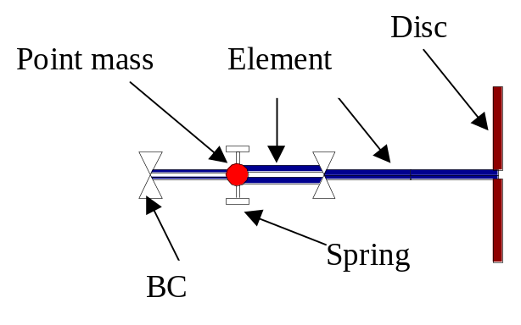
The interpretation of every symbol in the above drawing is explained.

The second input argument (GUI) makes the drawing mouse-click sensitive. Any input is valid (the program checks only for the existence of a second input argument). Clicking on one of the elements results in a title explaining the main properties of this element.

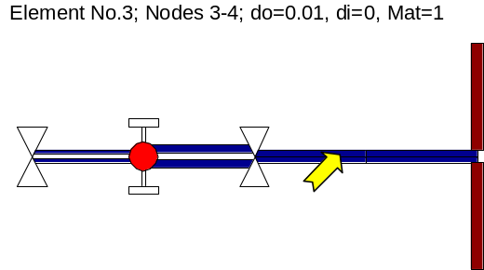
New modeshape/model overlay
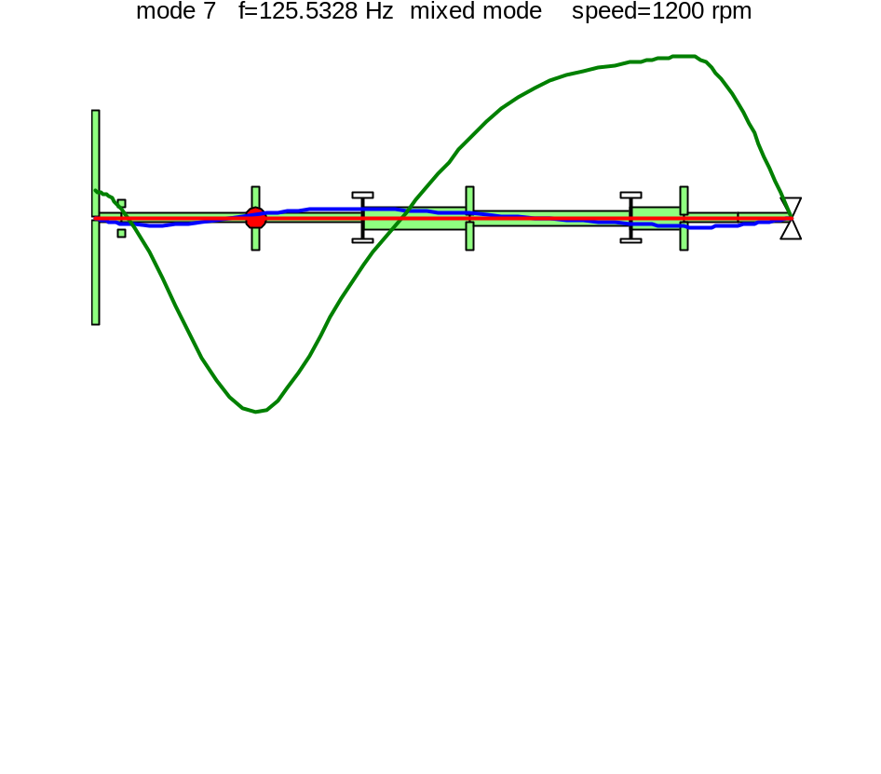

Theoretical background

Misalignment
Misalignment is usually introduced by the inevitable inaccuracy in the location of the supporting bearings. Misalignment can be resulted from unequal biasing currents in active magnetic bearings.
Misalignment is defined as the deviation from the imaginary centerline of the shaft in both the x and the y directions. In our model misalignment is realized by means of a static force that forces certain points along the shaft to be displaced by the so called misalignment.
Formulation:
static equilibrium 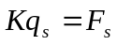
Since misalignment is caused by forces acting only at some nodal locations, i.e. acting upon some DOFS we may express the force as a linear combination of several forces:

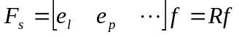
where 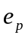 is the p^{th} column of the nxn identity matrix.
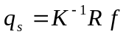

The selected DOFS at which we would like to define the misalignment are computed from
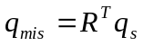
The required forces can be computed by
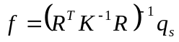
And finally expanded in the full dimension of the model
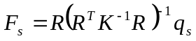

Example:
in the template file simple1, we define the misalignment, by
MISALIGN=[2 1e-3 .2e-3];
The model is run by
Rot=rotfe('simple1');
The required static force is Rot.Fmalgn
and the overall static displacement can be computed by
qs=Rot.K\Rot.Fmalgn;
and plotted by

[Wu Wv z]=rotmshape(qs,Rot);
plot3(z,Wu,Wv);
Example 2:
Misalignment in 2 locations
MISALIGN=[2 1e-3 0; 4 0 2e-3];
Rot=rotfe('simple1');
qs=Rot.K\Rot.Fmalgn;
[Wu Wv z]=rotmshape(qs,Rot);
plot3(z,Wu,Wv);

